Coursework 3 Mathematics for Machine Learning (CO-496)

CID:01366977 Name: Fanbo Meng

b) Contour graph with gradient descend showing alpha, beta and maxima.

*Startpoint:(0.5,0.5) stepsize=0.01 iteration times:200*

*We see that alpha=0.427792,beta=0.449088,maximum=-27.608803*

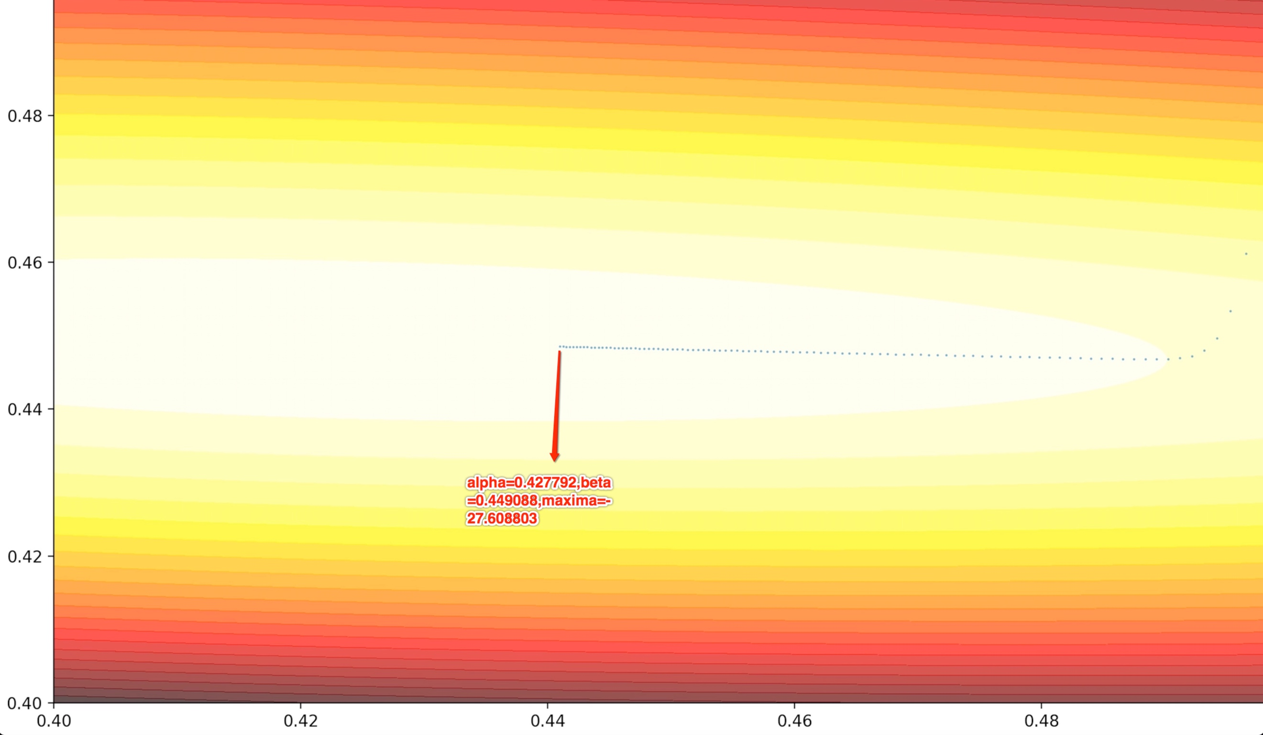

c)The log marginal likelihood for orders 0 to 11 is shown below and the test square error graph is indicated at the end (For illustration convenience). Briefly illustrated, MLE approximation assumes that before the training data appears, parameter is uniform distributed, MAP estimation takes consider in prior and pick up just one value of parameter, which is maximum posterior. These two approaches are examined by cross validation. In Bayesian approach, we assume that parameter is Gaussian distributed, and we take consider in each value of parameter, in this way, the performance is evaluated by the likelihood of data (how the training data fits the model).

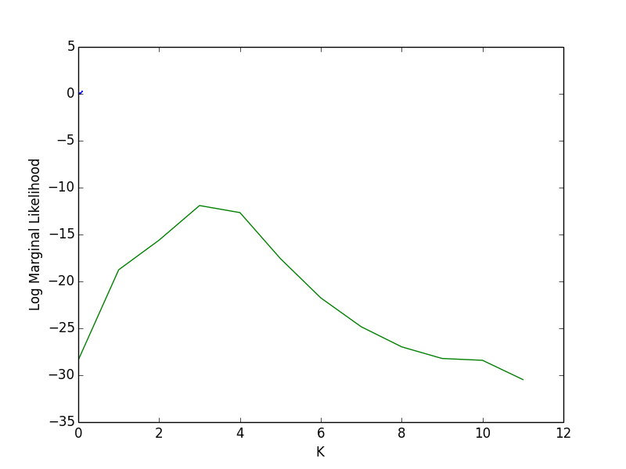

Bayesian approach: It can be seen that with the order increasing from 0 to 3, the log marginal likelihood is getting higher, when the order turns to 4, the likelihood decreases a little bit and then from 5 to 11, it decreases dramatically. When we are using Bayesian approach to analyze the parameter $α$ and $β$, with the increase of order, the training data actually suit the model worse. That is why the likelihood is getting smaller.

Cross validation approach: In cross validation approach, we only use the maximum likelihood approximation of *w* and the variance of Gaussian model $δ (means how sure or how close the data converges to mean)$, in this case, with the order increasing, even we can see that the model can suit the training data well, but the model itself is getting vulnerable indicated by the fact that the test behavior is poor.

In one word, these two approaches show that model behavior getting worse due to order increasing. However, they do it in separate ways. Bayesian one uses the extent in which the model suits training data(likelihood) to demonstrate this problem, while cross validation one use testing data to show the actually performance of this model to demonstrate this problem. Also, Bayesian approach take consider in the whole probability of *w* with a prior knowledge of how the parameters distribute*,* while MLE only take the maximum of *w.* The two approaches have advantages respectively. MLE simplifies the calculation but Bayesian approach takes consider comprehensively.



d) 